Difference Between Time Sharing and Real-Time Operating System

July 28, 2018 [Leave a Comment](https://techdifferences.com/difference-between-time-sharing-and-real-time-operating-system.html#respond)

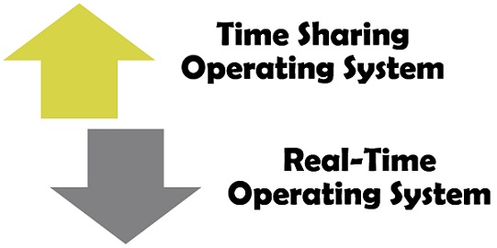The Time Sharing and Real Time operating systems are the types of operating systems which can be differentiated in many ways. The time sharing operating system is used to perform general tasks while real-time operating system tends to have a very specific task. The significant difference between time sharing and the real-time operating system is that time sharing operating systems concentrates on the generation of the quick response to the subrequest. On the other hand, the real-time operating system focuses on completing a computational task prior to the specified deadline.

Content: Time Sharing Operating System Vs Real-Time Operating System

* 1. [Comparison Chart](https://techdifferences.com/difference-between-time-sharing-and-real-time-operating-system.html#ComparisonChart)
  2. [Definition](https://techdifferences.com/difference-between-time-sharing-and-real-time-operating-system.html#Definition)
  3. [Key Differences](https://techdifferences.com/difference-between-time-sharing-and-real-time-operating-system.html#KeyDifferences)
  4. [Conclusion](https://techdifferences.com/difference-between-time-sharing-and-real-time-operating-system.html#Conclusion)

Comparison Chart

| **BASIS FOR COMPARISON** | **TIME SHARING OPERATING SYSTEM** | **REAL-TIME OPERATING SYSTEM** |
| --- | --- | --- |
| Basic | Emphasis on providing a quick response to a request. | It focuses on accomplishing a computational task before its specified deadline. |
| Computer resources | Shared between the user. | No sharing takes place and events are external to the system. |
| Process deals with | More than one application simultaneously. | Single application at a time. |
| Modification of the program | The programs can be modified and written by the users. | No modification is possible. |
| Response | The response is generated within the second, but there is no compulsion. | User must get the response within the defined time constraint. |
| Switching | Takes place among the processes. | Does not present |

Definition of Time Sharing Operating System

The **time sharing operating system** works on the multiprogramming concepts where multiple jobs are executed at the same time through switching them frequently. This switching is very fast so that the users can interact with each program while it is running without realising that the system is being shared.

Time sharing systems employ an interactive (or hands-on) computer system to enable straight communication between the system and the user. Here interactive means that the user will give the instructions to the system or program directly using an input device and the system will generate the results immediately on the output devices. The generation of the results consume very less time and its response time have to be short less than one second.

The time sharing operating system enable sharing of the computer resources to the multiple users at the same time. It requires less CPU time for each user as each command or action existing in a time shared system is short. The time shared systems employ a strategic CPU scheduling and multiprogramming to give each user a little amount of time shared system. Each user deals with at least one separate program in memory and which is known as a process while execution. It reduces the idleness of the CPU.

Definition of Real-Time Operating System

**Real-Time Operating System** mostly implemented on the embedded systems. A real-time operating system is very useful for the timing applications, in other words where tasks need to be accomplished within a certain time limit. It employs the strict timing constraints to drive execution of the tasks in an external environment.

The real-time operating systems not only require accurate results but also the timely results, which means along with the correctness of the results it must be produced in a certain time limit otherwise the system will fail. It is basically implemented in the applications which involve the control devices such as medical imaging systems, industrial control systems, automobile-engine fuel injection systems, weapon systems, etcetera.

Key Differences Between Time Sharing and Real-Time Operating System

1. In the time sharing operating systems, the computer resources are shared among the several users while in real-time systems the external events are processed within the deadline.
2. Real-time processing involves just one application. In contrast, the time sharing processing has to deal with several different applications.
3. In a real-time system, the user must get the response within a particular time-bound otherwise there are the chances of system failure. Conversely, the responses generated in the time-sharing systems are very swift and hardly take a fraction of second, but the outcome is not disastrous even if the response misses the moment of time.
4. Switching does not occur in case of real-time operating systems. On the contrary, the time sharing system uses context switching to switch the CPU from one to another process.